LELCLERCQ Vincent from 1rst April to 30th June 2015
DUBOIS Henri

Internship Report

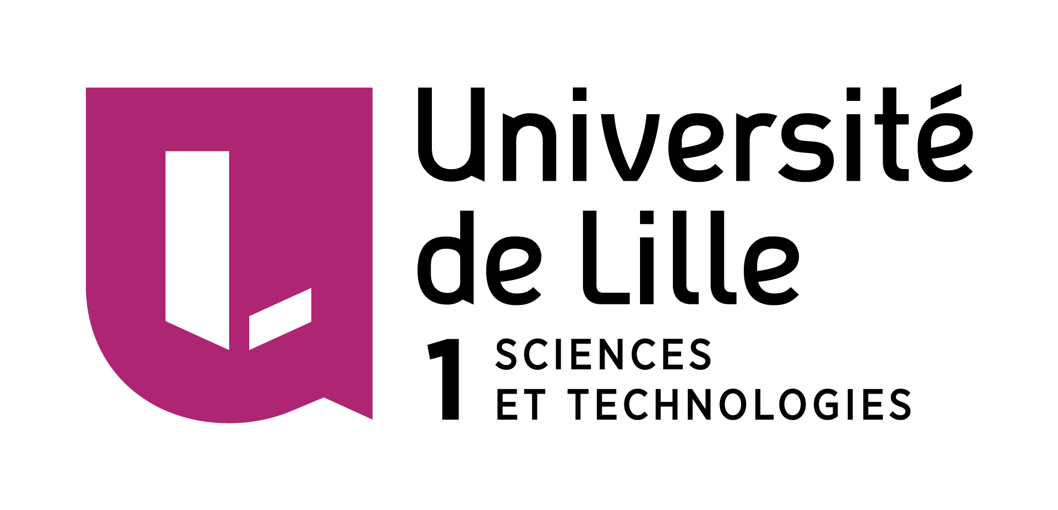


Mentors: Thomas Diette & Tomas Kazilionis

Acknowledgements

First of all, we wish to thank all the people who allowed us to do this internship far from Lille and to live this unforgettable experience.

We greatly thank Mr Kazilionis for his advice and for giving us this interesting subject which enabled us to discover new tools and learn many knowledge, we would give a special acknowledgement to Mr Stonys and Alytaus Kolegija for their welcoming and kindness.

Also we thank Ms Radlinskaitė for making us discover some Lithuanian culture through trips she organized, we really had many good times during those days.

Finally, thanks to our mentor Viktorija who helped us when we arrived, and to all residents of Alytaus Hostel, thank you for all the discoveries and their precious help all along our internship.

Abstract

When we chose to go for this 3-months Erasmus internship, we wanted to live a rewarding experience while acquiring new knowledge in the IT's field and increasing our english skills. Now that these three months have passed we believe we have achieved what we wanted.

During these months, we have completed a project that was given to us by Tomas Kazilionis, the creator of Public Secret Lt which is a company specialized on web development.

Our project is called “E-Testing System” and it consists to create a dynamic website that helps make life easier for teachers, indeed by using our E-Testing System, teachers and everyone can create tests easily and send it to persons of their choice to see their answers immediately.

Create this project step by step enabled us to learn by ourselves because it requires tools that we had never studied, that made us enthusiastic and motivated.

Table of Contents
Acknowledgements 2
Abstract 3
Introduction 4
Context of our internship 5
7
E testing project 7

Introduction

The DUT in computer science is a two-year diploma. Those have obtained it have the choice to continue their studies or seek an employment in a company. This internship at Alytaus Kolegija is the end point of our two last years of studies in Université de Lille and we know that we were lucky to to have lived such an experience. Through this we tested our working capacity, our autonomy and this allowed us to improve it.

This report consist in three parts. Firstly we will describe our work condition and introduce our project. Then we will explain how we did to achieve, how to use it and also why to use it. Finally, we will do a review of the last three months we spent at Alytus and what it has brought us.

Context of our internship

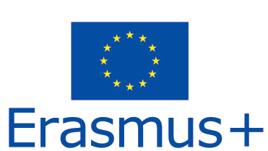
This internship was an erasmus+ program which was proposed to us by our university of Lille. When we knew that we had the opportunity to live such an experience in a foreign country we immediately asked to be part of it.

ERASMUS (European Action Scheme for the Mobility of University Students) is a European Union student exchange programme thats allows European students to live and study in another country since 1987.

Host place

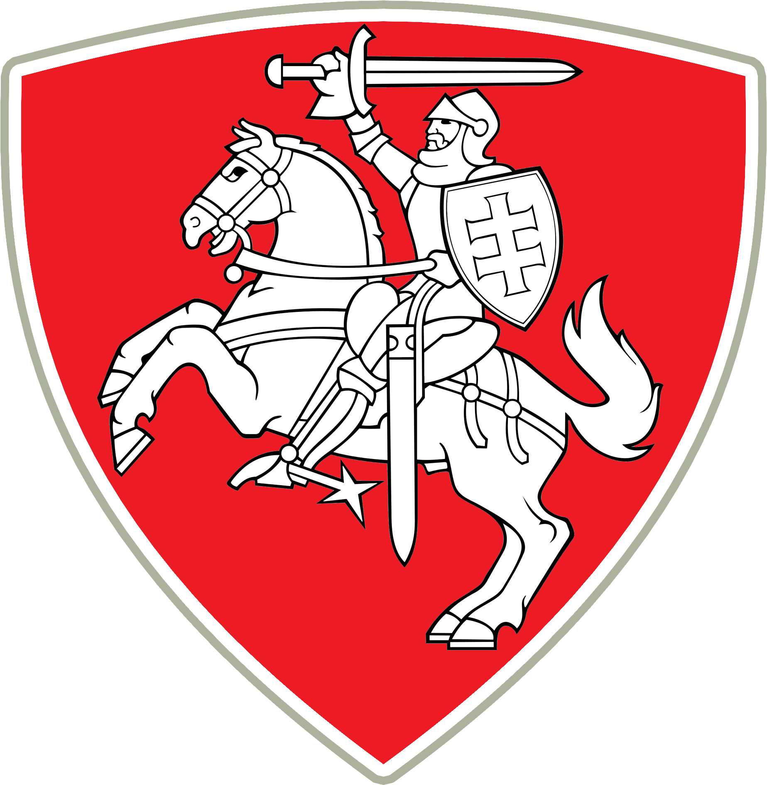
Lithuania was our host country during our internship. It's a 3-millions habitants country situated along the Southern shore of the Baltic sea.

Vilnius which is the largest city, is also the capital of Lithuania. This country is a member of the European Union since 2004 and adopted the euro as the official currency on the 1st January 2015.


Before coming to work in Lithuania we didn't know such things about this country so we were very impatient to discover it.
This internship enables us to learn a lot about local culture through trips and by going out with friends. We visited the biggest cities of Lithuania and we met a lots of friendly people here.



Alytus is the sixth largest city in Lithuania, it is crossed by a river called the Nemunas river. The population is about 55 000 habitants and it takes us almost two hours to cover the 100 kilometers between Vilnius and the city of Alytus.

During these three months we worked for the Alytaus Kolegija, which is a university of applied science

E-Testing project

Develepement web

PHP
JAVASCRIPT
HTML
CSS

Tools

